**Results for building life cycle cost assessment**

**according to ISO 15686-5 & EN 16627**



**Project name**

Address: *[Address, Country]*

Assessor:

Client for assessment:

Date:

*[Text marked with blue color and brackets contains guidance. Remove from the final report.]*

Contents

1. Purpose of the study and description of the building 3

2. Life cycle cost assessment result summary 3

3. Life cycle costing assessment scope and system boundaries 4

4. Parameters of the analysis 7

5. Data sources 7

6. Detailed assessment results and analysis 9

7. Description of One Click LCA calculation tool 11

# Purpose of the study and description of the building

**Assessment basic information:**

Purpose of the study: *[purpose of the LCC study, e.g* *building certification]*  
Project type: *[new construction / renovation, point of assessment in building’s life cycle]*

Level of reliance: *[Calculations of LCC can be made at various levels depending on which phase of the project process is involved. The degree of detail and information available should play a decisive role. The general principle that determines the level of detail at which calculations of LCC are made should be the corresponding level of detail employed to calculate the acquisition costs. e.g. detailed LCC analysis, benchmark LCC analysis.]*

Assessment method: ISO 15686-5 & EN 16627

**Assessed building, general information:**

Building type: *[e.g. office, residential building]*

Construction year:

Building area:  *[specify also the unit, dependent on the purpose of your LCC study, e.g. NFA, BTA, or other]*  
Building function(s) and service(s): *[Description of building use / functions including areas of different functions]*

Extent of use: *[number of users / occupants, pattern of use/occupancy]*

Relevant technical and functional requirements: *[Building use and technical information. Describe shortly*

*Technical, functional and qualitative properties of the building such as:*

* *building form e.g. high rise, low rise, free-standing or detached, number of floors*
* *servicing type e.g. heating, cooling, ventilation and hot water service system type, are the systems centralized*
* *conditions of use (according to national energy performance calculation method)*
* *other relevant client or regulatory requirements]*

Required service life: *[Service life of the building required by the client or through regulations, for LCC this is also the reference study period / calculation period for the analysis]*

# Life cycle cost assessment result summary

The life cycle cost assessment was calculated using One Click LCA. The results are summarized in the following table. The results represent the total life cycle costs during *[enter here required service life / calculation period]* years.

Table . LCC result summary

|  |  |  |
| --- | --- | --- |
| Life cycle module | Life cycle costs, discounted (*Currency*) | Life cycle costs, real (*Currency*) |
| A0-A5 (Construction; capital costs) |  |  |
| B1-B3 (Operating costs) |  |  |
| B4-B5 (Replacement/Refurbishment) |  |  |
| B6 (Operational energy use) |  |  |
| B7 (Operational water use) |  |  |
| C1-C4 (End of life) |  |  |
| Total |  |  |
| Results per building area |  |  |

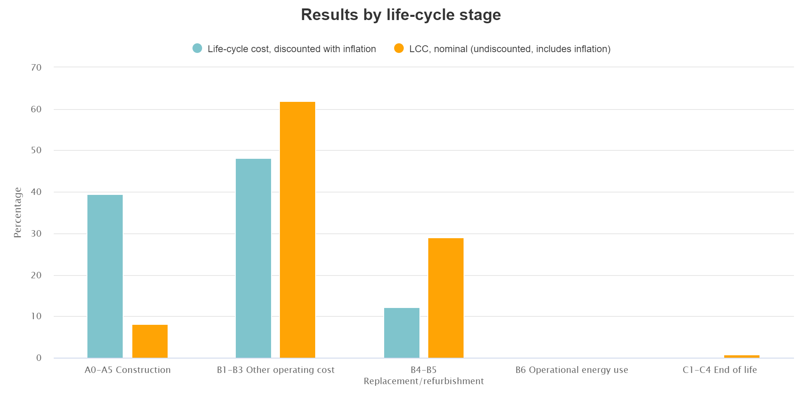

Figure 1. Accumulation of costs over life cycle

*[Insert here your summary graph of results (download from project result page).]*

# Life cycle costing assessment scope and system boundaries

In the assessment following life cycle stages according to EN 16627 were included:

|  |  |  |  |  |  |  |  |  |  |  |  |  |  |  |  |  |  |  |  |  |
| --- | --- | --- | --- | --- | --- | --- | --- | --- | --- | --- | --- | --- | --- | --- | --- | --- | --- | --- | --- | --- |
| **Pre-construction stage** | **Product Stage** | | | | **Construction Process Stage** | | **Use Stage** | | | | | | | **End-of-Life Stage** | | | | **Benefits and loads beyond the system boundary** | | |
| Activity carried out before a development site is selected | Raw material supply | Transport | Manufacturing | Transport to building site | | Installation into building | Use/application | Maintenance | Repair | Replacement | Refurbishment | Operational energy use | Operational water use | Deconstruction/demolition | Transport | Waste processing | Disposal | Reuse | Recovery | Recycling |
| A0 | A1 | A2 | A3 | A4 | | A5 | B1 | B2 | B3 | B4 | B5 | B6 | B7 | C1 | C2 | C3 | C4 | D | D | D |
| x | | | | | | | x | | | x | | x | x | x | | | | MNA | | |

Figure 2. Life cycle stages included in the assessment

Description of the life cycle modules and analysis scope are provided in the table below:

Table 2. Explanation of life cycle modules and analysis scope.

|  |  |
| --- | --- |
| **Life cycle module** | **Analysis scope** |
| A0-A5 Pre-construction and before use stage | Costs of purchase or rental costs (costs of the site); costs of building products; costs related to the transport between factory and site; project feasibility, planning, design, engineering and construction costs, incl. permissions, commissioning and handover; site clearance and landscaping (e.g. lawn, trees, and similar within the curtilage and other external works costs; subsidies and incentives (e.g. incomes related to renewable energy) |
| B1-B3 Operation and maintenance costs | Building related facility management costs (e.g. regular cleaning, insurance, security, fire inspection and similar costs); repair costs; ground maintenance; redecoration |
| B4-B5 Replacement/refurbishment | Planned adaptation or refurbishment (incl. infrastructure, fitting out and commissioning, validation and handover); replacement of major systems and components (incl. associated design and project management) |
| B6 Operational energy use | Energy costs (incl. fuel and electricity for heating, cooling, power, domestic hot water and lighting, as per EPBD) |
| B7 Operational water use | Water related costs (e.g. rates, local charges, environmental taxes) |
| C1-C4 Deconstruction | Demolition costs; transport costs associated with deconstruction and disposal; fees & taxes (e.g. landfilling); waste processing costs |

The LCC analysis includes costs elements reported in the table below, using the data as stated.

Table 3. Scope of analysis and data sources

|  |  |  |  |
| --- | --- | --- | --- |
| **Element** | **Included** | **Comments** | **Data sources for building specific input data** |
| **CONSTRUCTION (A0-A5)** |  |  | *[Data is based on estimations/based on real values for assessed project/other.]* |
| Planning, design and supervision (A0) | *Yes/No* |  |
| Permits and licenses (A0) | *Yes/No* |  |
| Land purchase (A0) | *Yes/No* |  |
| Soil studies and comparable (A0) | *Yes/No* |  |
| Realty procurement (A0) | *Yes/No* |  |
| Construction costs (A1-A5) *Scope included in the table 4* | *Yes/No* |  | *[List design data source used such as building information model, architectural drawings etc.*  *Define if you used project specific data or automated scenarios for costs from One Click LCA.]* |
| Other costs (A0-A5) | *Yes/No* |  |
| **OPERATION, MAINTENANCE AND REPAIR (B1-B3)** |  |  |  |
| Cleaning (B2) | *Yes/No* | *Including regular cyclical cleaning and periodic specific cleaning* | *[State the source for operation and maintenance costs or state that One Click LCA automated values were used. If data sources are mixed, then specify which data was used for specific cost element.]* |
| Land rental (B2) | *Yes/No* |  |
| Insurance (B2) | *Yes/No* | *Building owner and/or occupiers* |
| Property taxes (B2) | *Yes/No* |  |
| Security services (B2) | *Yes/No* |  |
| Facility management (B2) | *Yes/No* |  |
| External area management (B2) | *Yes/No* | *Within defined site area* |
| Inspections (B2) | *Yes/No* |  |
| Maintenance and upkeep (B1-B3) | *Yes/No* | *Cyclical inspections, design of works, management of planned service contracts* |
| Waste management cost (B2) | *Yes/No* |  |
| Repair projects (B3) | *Yes/No* | *Defining by value, size of area, contract terms* |
| Annual repairs budget (B3) | *Yes/No* |  |
| Other costs (B1-B3) | *Yes/No* |  |
| **REPLACEMENT/REFURBISHMENT (B4-B5)** | *Yes/No* |  | A1-A5 construction materials related data is used together with the material/element service life data (B1-B5). |
| **OPERATIONAL ENERGY (B6)** | *Yes/No* | *Including fuel for heating, cooling, power, lighting* | *[Define which source you used e.g. energy modelling, energy certificate etc. For instance: Energy consumption was estimated based on design stage energy simulation with project specific use scenarios.*  *State what is the source for energy costs or state that calculation tool automated values were used].* |
| **OPERATIONAL WATER (B7)** | *Yes/No* |  | *[Define which source you used. For instance: Water consumption was estimated based on typical water consumption for office buildings.*  *State* *what is the source for water costs or state that calculation tool automated values were used].*] |
| **END-OF-LIFE (C1-C4)** | *Yes/No* |  | Capital expenditure costs are basis for end-of-life costs. *[State the source for End-of-life costs calculation % or state that calculation tool automated % was used. Automated values are based on averaged estimations].* |

Table 4. Scope of included materials

|  |  |  |
| --- | --- | --- |
| **Element** | **Included** | **Comment *[mark if something is not relevant or explain why it is excluded]*** |
| **SUPERSTRUCTURE** |  |  |
| Frame | *Yes/No* |  |
| Upper floors | *Yes/No* |  |
| Roof | *Yes/No* |  |
| Stairs | *Yes/No* |  |
| External Walls | *Yes/No* |  |
| Windows & External doors | *Yes/No* |  |
| Internal Walls and Partitions | *Yes/No* |  |
| Internal Doors | *Yes/No* |  |
| **INTERNAL FINISHES** |  |  |
| Wall Finishes | *Yes/No* |  |
| Floor Finishes | *Yes/No* |  |
| Ceiling Finishes | *Yes/No* |  |
| **BUILDING FITTINGS & FURNISHINGS** |  |  |
| Fixed fittings and equipment | *Yes/No* |  |
| **SERVICES** |  |  |
| Sanitary Fittings | *Yes/No* |  |
| Services Equipment | *Yes/No* |  |
| Disposal Installations | *Yes/No* |  |
| Water Installations | *Yes/No* |  |
| Heat Source | *Yes/No* |  |
| Space Heating and Air Treatment | *Yes/No* |  |
| Ventilation Systems | *Yes/No* |  |
| Electrical Installations | *Yes/No* |  |
| Gas Installations | *Yes/No* |  |
| Lift Installations | *Yes/No* |  |
| Protective Installations, inc. internal CCTV | *Yes/No* |  |
| Communication Installations | *Yes/No* |  |
| Specialist Installations | *Yes/No* |  |
| **EXTERNAL WORKS** |  |  |
| Site works | *Yes/No* |  |
| Drainage | *Yes/No* |  |
| External services | *Yes/No* |  |

# Parameters of the analysis

*[Enter here calculation parameters from the LCC result page]*

Table . LCC calculation parameters

|  |  |
| --- | --- |
| Calculation period |  |
| Currency |  |
| Discount rate (cost of capital) |  |
| Regional material cost index |  |
| General inflation rate |  |
| Energy inflation rate |  |
| Water inflation rate |  |
| EOL as % of capex |  |
| Hourly labour rate worker |  |
| Hourly labour rate craftsman |  |

# Automated data sources

The assessment was calculated in One Click LCA software using Life-cycle cost, automated (ISO 15686-5 & EN 16627) tool.

The automated datasets for material costs are put together based on Neubau Baupreise Kompakt; Statistische Baupreise für Positionen mit Kurzttexten (BKI) (2017) and Spon's Architects' and Builders' Price Book (AECOM) (2017) and include modifications for different regions related to labour costs and cost indexes.

Labor costs are based on International Labour Organization. Labour costs. 2016.

Maintenance costs are based on Whitestone Facility Operations Cost Reference, International (2014) and Whitestone Facility Maintenance And Repair Cost Reference, International (2013) and include modifications for different regions related to labour costs and cost indexes.

End-of-life costs are calculated based on the capital costs. The end-of life is a percentage of capital costs, which is based on averaged projects.

# Assumptions

Assumptions (if relevant):

*[List here all assumptions made for the assessment; e.g. if some cost elements were left out from the LCC; some material quantities were rounded or estimated; and similar]*

Table . Assumptions

|  |  |
| --- | --- |
| Cost item | Comment |
|  |  |
|  |  |

# Detailed assessment results and analysis

*[Copy here charts from the results page and tables from the Details view (button at the end of each reported life cycle module)].*

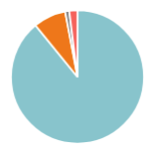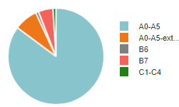

Figure 3. Discounted and real costs in different life cycle modules

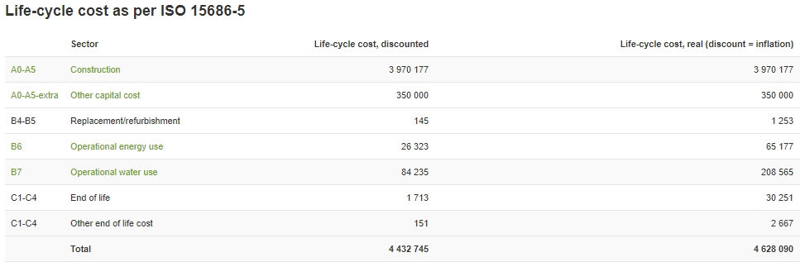Table 8. Life cycle cost as per ISO 15686-5

*[Enter here Details of at least 3 cost groups, which contribute the most to the Totals. E.g. Construction costs]*

Table 9. Cost of Construction (A0-A5)

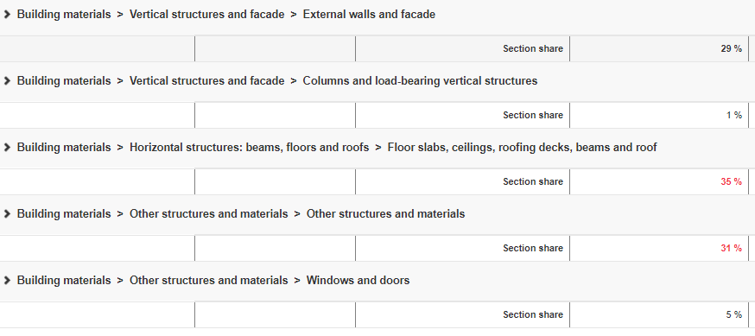

The results of the assessment demonstrate, that the *[state the module with the highest share; add “-extra” modules, as necessary]*, *[state the module with the second highest share; add “-extra” modules, as necessary]* and *[state the module with the third highest share; add “-extra” modules, as necessary]* module contribute the most to the construction life cycle costs.

Within *[state the module with highest share]* life cycle module the following elements are contributing the most to the overall costs:

* *[state the cost element with the highest share]*
* *[state the cost element with the second highest share]*
* *[state the cost element with the third highest share]*
* *Add more if necessary*

*Add similar summary for other modules if relevant.*

Based on these results, following decisions were made for the project:

*[Describe the outcomes of the LCC study. E.g.*

* *It was decided to change the roofing material to metal roofing due to the lower overall costs of the selection over its’ life cycle.*
* *The water equipment was reconsidered and more efficient appliances were selected.*

# Description of One Click LCA calculation tool

The calculations were performed with One Click LCA calculation tool. The tool is developed to be in line with ISO 15686 and EN 16627 standards. One Click LCA has been third party verified by ITB for compliancy with the following LCA standards: EN 15978, ISO 21931–1 and ISO 21929, and data requirements of ISO 14040 and EN 15804. You can find the official letters of compliancy here: https://www.oneclicklca.com/wp-content/uploads/2016/11/360optimi-verification-ITB-Certificate-scanned-1.pdf.

*ITB is a certification organization and a Notified Body (EC registration nr. 1488) to the European Commission designated for construction product certification. Polish Accreditation Board assures the independence and impartiality of ITB services (Accreditation Certificates are: AB 023, AC 020, AC 072, AP 113). ITB activities are conducted in accordance to the requirements of the following assurance standards: ISO 9001, ISO/IEC 27001, ISO/IEC 17025, EN 45011, and ISO/IEC 17021.*