One Click LCA® – Result reporting template for LEED v4 MRc1 Building Life-Cycle Impact Reduction, Option 4
Life cycle assessment results for achieving credits for LEED v4 MRc1 Building Life-cycle Impact reduction credit and its option 4: Whole building impact assessment.

Project name
Address:
Author:
Date:

[Text marked with blue color and brackets contains guidance. Remove from the final report.]

Contents
1. Life cycle impact assessment result summary 3
2. The life cycle assessment scope and service life 3
3. Description of the datasets 4
4. Analysis material scope 4
5. Description of Baseline building and explanation of equivalence 5
6. Description of Proposed building 7
7. The detailed assessment results 8
8. Description of One Click LCA calculation tool 9

Life cycle impact assessment result summary
The life cycle assessment was calculated using One Click LCA. The results are summarized in following table. The results represent the total life cycle impact during 60 year service life.
Impact category | Unit | Baseline result | Proposed design result | Reduction, %
Global warming potential (greenhouse gases) | kgCO₂ eq
Depletion of the stratospheric ozone layer | kgCFC-11 eq
Acidification of land and water sources | kgSO₂ eq
Eutrophication | PO₄³eq
Formation of tropospheric ozone(photochemical oxidant formation) | C₂H₄eq
Depletion of non-renewable energy resources | MJ

Number of environmental impact categories with more than 10 % reduction:
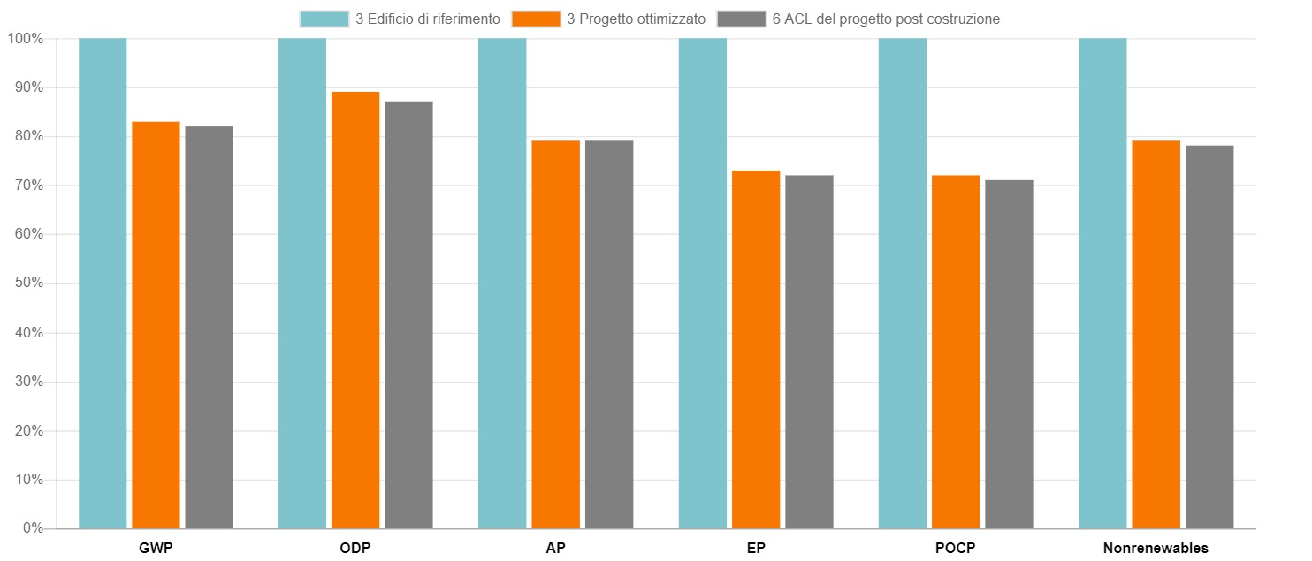[Insert here your summary graph of results comparing the proposed building to baseline building. (copy from project main page).]

The life cycle assessment scope and service life
One Click LCA tool was used to model both baseline and proposed building.
In the assessment following life cycle stages according to EN 15804 (2012) were included:
- A1-A3 Construction Materials
- A4 Transportation to site
- B1-B5 Maintenance and material replacements
- C1-C4 Deconstruction

Building service life was estimated to be 60 years which is fixed in the tool settings.

Description of the datasets
One Click LCA calculation tool was used for the analysis. All of the datasets in the tool follow ISO14044 standard.
One Click LCA calculation tool was used for the analysis. All of the datasets in the tool follow ISO14044 standard.
The One Click LCA LEED LCA tool for European /International markets was used in the assessment. The tool supports CML (2002 - November 2012 or never) methodology and all required IMPACT categories.
Special note for CML: Depletion of non-renewable energy resources — for CML, Full Reference Guide specifies “weight or volume of raw material”, and separately: for the purposes of complying with this credit, depletion means “the amount used”. One Click LCA implements in the LCA for LEED (CML) application in the impact category “Depletion of non-renewable energy (MJ)”, which is the one required to be reported by the LEED v4’s dynamic PDF forms.

Analysis material scope
The material scope in was the same in both baseline and proposed design. The LCA analysis included following building elements:
Element | Included | Comment (mark if something is not relevant)
Standard foundations | Yes
Special foundations | Yes
Slab on Grade | Yes
Basement excavation | No
Basement Walls | Yes
Columns | Yes
Beams
Floor Construction | Yes
Floor / Ceiling Finishes | ? | Optional
Roof Construction | Yes
Exterior and Semi-exterior Walls from cladding to finishing | Yes | Semi-exterior elements separate conditioned space from unconditioned space or that encloses semi-heated space (e.g., attic, crawl space, and basement).
Exterior Windows | Yes
Exterior Doors | Yes
Roof Coverings | Yes
Roof Openings | Yes
Load-Bearing partitions | Yes
Other Partitions | ? | Optional
Interior Doors | ? | Optional
Fittings | No
Stair Construction | Yes
Stair Finishes | ? | Optional
Wall finishes | Yes | For included walls only
Parking structures | Yes
Parking lots | No

As per LEED v4 specification following elements were excluded from the analysis: electrical and mechanical equipment and controls, plumbing fixtures, fire detection and alarm system fixtures, elevators, and conveying systems, excavation and other site development, parking lots.

Description of Baseline building and explanation of equivalence
[Guidance: Choose one of the options below based on the baseline strategy:]
[Option 1, modifying the baseline from existing building model, design alternative:]
The baseline was created based on the proposed building design to ensure the equivalence of the proposed design and baseline in all required aspects including same area, location, function, energy performance, and directional exposure. The baseline building was created by changing the material definitions within One Click LCA tool.
The equivalence in energy performance and exposure conditions was ensured by following aspects:
- All alternative enclosure roof, wall and slab materials were modelled with similar R-value / U-value / F-Factor to ensure similar energy loss through the structure
- The size and location of the windows and skylights were kept similar in both models to ensure similar energy loss through the structure
- Structural elements were modelled with required load bearing capacity

[If you have changed any of the above, clarify the equivalence.]
Differences between the baseline and proposed building and the evidence in the equivalence in performance are explained in the table below.
[Explain in the following table how the structures fulfill requirements for equivalence:
- functional requirements e.g. load bearing capacity,
- provide similar energy performance (evidence on U-values, R-values or F-factors)
- If you have changed structure service life evidence on how longer service life is reasoned for instance due to better material technical properties
- If you have changed material transport distances evidence how you can shorten the distance
- International projects only: How the chosen structures represents locally typical/legal choices]

Baseline material / construction | Proposed material / construction | Equivalence in performance

Option 2, using early stage or alternative design model as a baseline:
The baseline was created based on an early stage design option of the building. The equivalence in the programmatic function, area, location and directional exposure were the same in both of the models as they were designs of the same building. The baseline building was created by adding the alternative design model to One Click LCA tool.
The equivalence was ensured by following aspects:
- All alternative enclosure roof, wall and slab materials were modelled with similar R-value / U-value / F-Factor to ensure similar energy loss through the structure
- The size and location of the windows and skylights were kept similar in both models to ensure similar energy loss through the structure
- Structural elements were modelled with required load bearing capacity

Differences between the baseline and proposed building and the evidence in the equivalence in performance are explained in the table below.
[Explain in the following table how the structures fulfill requirements for equivalence:
- functional requirements e.g. load bearing capacity,
- provide similar energy performance (evidence on U-values, R-values or F-factors)
- If you have changed structure service life evidence on how longer service life is reasoned for instance due to better material technical properties
- If you have changed material transport distances evidence how you can shorten the distance
- International projects only: How the chosen structures represents locally typical/legal choices]

Baseline material / construction | Proposed material / construction | Explanation of equivalence in performance (energy, functional requirements)

[Option 3, using archetype design:]
The baseline building was created by using the size, orientation, location, directional exposure and function of the proposed building but by replacing the structures with structures of a local archetype building. The impacts of the archetype building structures calculated with to One Click LCA.
The equivalence was ensured by following aspects:
- All alternative enclosure roof, wall and slab materials were modelled with similar R-value / U-value / F-Factor to ensure similar energy loss through the structure
- The size and location of the windows and skylights were kept similar in both models to ensure similar energy loss through the structure
- Structural elements were modelled with required load bearing capacity

Differences between the baseline and proposed building and the evidence in the equivalence in performance are explained in the table below.
[Guidance: Explain in the following table how the structures fulfill requirements for equivalence:
- functional requirements e.g. load bearing capacity,
- provide similar energy performance (evidence on U-values, R-values or F-factors)
- If you have changed structure service life evidence on how longer service life is reasoned for instance due to better material technical properties
- If you have changed material transport distances evidence how you can shorten the distance]
- International projects only: How the chosen structures represents locally typical/legal choices]

Description of change |  | Explanation of equivalence in performance (energy, functional requirements)
Baseline | Proposed

Description of Proposed building
The proposed building was calculated in One Click LCA based on design data from [add here the description of the datasource and how analysis was executed.]

The detailed assessment results
As both proposed design and the proposed design were calculated separately the result tables for both of them are added here separately. Additionally a comparison table of all of the results is shown
Results for the baseline design
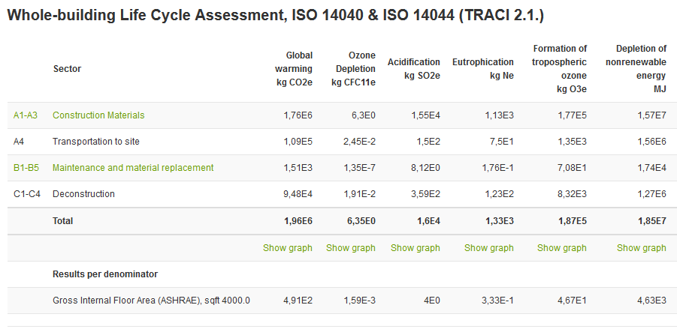
[Add here your result tables from One Click LCA.]
Results for the baseline design
[Add here your result tables from One Click LCA.]

Results for the proposed design and comparison
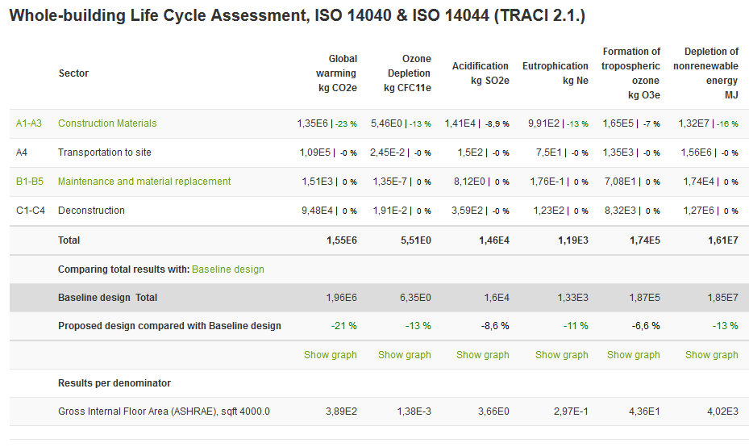
[Guidance: Add here the comparison result tables from proposed design that shows the percentage differences.]

Description of One Click LCA calculation tool
The calculations were performed with One Click LCA calculation tool. The software is fully compliant with LEED v4 BD+C manual and “Full Reference Guide LCA text”. One Click LCA has been third party verified by ITB for compliancy with the following LCA standards: EN 15978, ISO 21931–1 and ISO 21929, and data requirements of ISO 14040 and EN 15804. You can find the official letters of compliancy here: https://www.oneclicklca.com/wp-content/uploads/2016/11/360optimi-verification-ITB-Certificate-scanned-1.pdf.
ITB is a certification organization and a Notified Body (EC registration nr. 1488) to the European Commission designated for construction product certification. Polish Accreditation Board assures the independence and impartiality of ITB services (Accreditation Certificates are: AB 023, AC 020, AC 072, AP 113). ITB activities are conducted in accordance to the requirements of the following assurance standards: ISO 9001, ISO/IEC 27001, ISO/IEC 17025, EN 45011, and ISO/IEC 17021.

