One Click LCA® – Result reporting template for BREEAM UK New Construction Mat 01 life cycle assessment for client reporting
Life cycle assessment results for achieving credits for BREEAM UK New Construction 2011 and 2014 Mat 01 life cycle assessment exemplary credit.

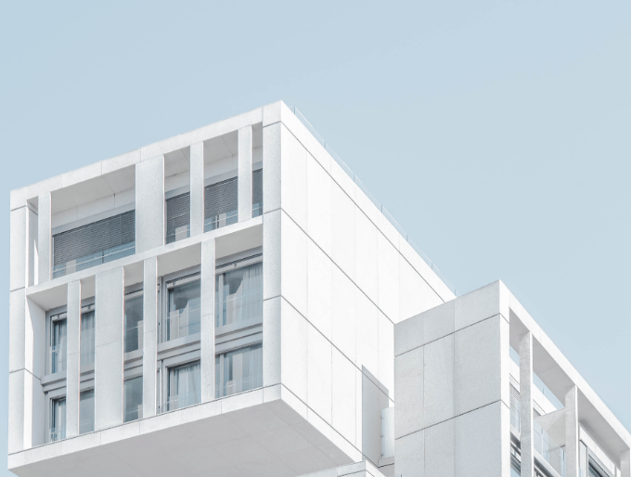
Insert your own picture here

Project name
Address:
Author:
Date:

[Text marked with blue color and brackets contains guidance. Remove from the final report.]
Contents
1. Life cycle impact assessment result summary 3
2. The life cycle assessment scope and service life 3
3. Description of the datasets 4
4. Analysis material scope 4
5. Description of Baseline building and explanation of equivalence 5
6. Description of Proposed building 7
7. The detailed assessment results 8
8. Description of One Click LCA calculation tool 9

Life cycle impact assessment result summary
The life cycle assessment was calculated using One Click LCA which is officially approved for the BREEAM UK Mat 01 credit by BRE. The results are summarized in following table and graph. The results represent the total life cycle impact during 60 year service life according to BS EN 15978:2011 for the proposed design.
Assessment results for proposed design for seven assessed impact categories are presented in table and graph below. [You can choose the relevant impact categories but include at least global warming potential]
Impact category | Unit | Result
Global warming potential (greenhouse gases) | kgCO₂ eq
Depletion of the stratospheric ozone layer | kgCFC-11 eq
Acidification of land and water sources | kgSO₂ eq
Eutrophication | PO₄³eq
Formation of tropospheric ozone (photochemical oxidant formation) | C₂H₄eq
Abiotic depletion potential, non -fossil | MJ
Abiotic depletion potential, fossil resources | kgSb

The results for different life cycle stages are also shown in the graph below.
[Insert result graph here]
The detailed results are shown in attached Excel according to the credit reporting requirements.

The life cycle assessment scope and service life
One Click LCA tool was used to model the building.
[IMPACT Compliant tool:]
The assessment covered following impact categories:
Environmental impacts | Energy | Resources | Waste
Global warming potential | Use of non-renewable primary energy as energy | Use of secondary materials | Hazardous waste disposed
Ozone depletion potential | Use of non-renewable primary energy as material | Use of renewable secondary fuels | Non-hazardous waste disposed
Acidification | Total use of non-renewable primary energy | Use of non-renewable secondary fuels | Radioactive waste disposed
Eutrophication | Use of renewable primary energy as energy | Use of net fresh water | Highly radioactive waste disposed
Formation of ozone at lower atmosphere | Use of renewable primary energy as material | Components for re-use
Abiotic depletion potential, non -fossil | Total use of renewable primary energy | Materials for recycling
Abiotic depletion potential, fossil resources |  | Materials for energy recovery
 |  | Exported energy
Ecopoints

The assessment covered full life cycle according to BS EN 15978:2011 including:
- A1-A3 Construction Materials
- A4 Transport
- A5 Construction site impacts¹⁾
- B1-B7 Use, maintenance, replacements and refurbishment, operational energy and water
- C1-C4 End of life
Building service life was estimated to be 60 years which is fixed in the tool settings.
Following life-cycle modules are not assessed (MNA): -

Description of the datasets
IMPACT database was used for the analysis. Database contains average materials for construction materials life cycle emissions and building use phase water and energy consumption based on UK market according to EN 15804 standard including all the impact categories of the standard.

Analysis material scope
The material scope is according to the Guidance note 08. The LCA analysis included following building elements:
 | Category |  | Sub category |  |  | Sub category | Included | Comment / not applicable
1 | Substructure | 1 | Substructure | 1 |  | Standard foundations | Yes
 |  |  |  | 2 |  | Specialist foundation systems | Yes
 |  |  |  | 3 |  | Lowest floor construction | Yes
 |  |  |  | 4 |  | Basement excavation (fuel use) | Yes | Can be aggrecated
 |  |  |  | 5 |  | Basement retaining walls (2.5.2) | Yes
2 | Superstructure | 1 | Frame (excl. floors) | 1 |  | Steel frames | Yes
 |  |  |  | 2 |  | Space decks | Yes
 |  |  |  | 3 |  | Concrete casings to steel frames | Yes | Aggregated to x?
 |  |  |  | 4 |  | Concrete fames | Yes
 |  |  |  | 5 |  | Timber frames | Yes
 |  |  |  | 6 |  | Other frame systems | Yes
 |  | 2 | Upper Floors | 1 |  | Floors | Yes
 |  |  |  | 2 |  | Balconies | ? | Optional
 |  |  |  | 3 |  | Drainage to balconies | ?
 |  | 3 | Roofs | 1 |  | Roof structure | Yes | Aggregated to x?
 |  |  |  | 2 |  | Roof covering | Yes | Aggregated to x?
 |  |  |  | 3 |  | Specialist roof systems | Yes | Aggregated to x?
 |  |  |  | 4 |  | Roof drainage | ? | Optional
 |  |  |  | 5 |  | Rooflights, skylights and openings | Yes
 |  |  |  | 6 |  | Roof features | ? | Optional
 |  | 4 | Stairs and ramps | 1 |  | Stair / Ramp structures | Yes
 |  |  |  | 2 |  | Stair / Ramp finishes | ? | Optional
 |  |  |  | 3 |  | Stair / Ramp balustrades, handrails | ? | Optional
 |  |  |  | 4 |  | Ladders / Chutes / Slides | ? | Optional
 |  | 5 | External walls | 1 |  | External enclosing walls above ground floor level | Yes
 |  |  |  | 2 |  | External enclosing walls below ground level | Yes
 |  |  |  | 3 |  | Solar / Rain screening | Yes | Aggregated to x?
 |  |  |  | 4 |  | External soffits | Yes
 |  |  |  | 5 |  | Subsidiary walls, balustrades, handrails, railings and  proprietary balconies | ? | Optional
 |  |  |  | 6 |  | Façade access / cleaning systems | ? | Optional
 |  | 6 | Windows, ext. doors | 1 |  | External Windows | Yes
 |  |  |  | 2 |  | External doors | Yes
 |  | 7 | Internal Walls | 1 |  | Walls and partitions | Yes
 |  |  |  | 2 |  | Balustrades and handrails | ? | Optional
 |  |  |  | 3 |  | Moveable room dividers | ? | Optional
 |  |  |  | 4 |  | Cubicles | ? | Optional
 |  | 8 | Internal Doors | 1 |  | Internal Doors | Yes
3 | Internal Finishes | 1 | Wall Finishes | 1 |  | Finishes to walls | Yes | Aggregated to x?
 |  | 2 | Floor Finishes | 1 |  | Finishes to floors | Yes
 |  |  |  | 2 |  | Raised access floors | Yes
 |  | 3 | Ceiling Finishes | 1 |  | Finishes to ceilings | Yes
 |  |  |  | 2 |  | False ceilings | Yes
 |  |  |  | 3 |  | Demountable suspended ceilings | Yes
4 | Fittings, Furnishing and Equipment |  |  |  |  |  | ? | Optional
5 | Services (note: category may be used for operational/in-use fuel and energy use) |  |  |  |  |  | ? | Optional
8 | External works | 2 | Roads, Paths, Pavings | 1 |  | Roads, paths and pavings | Yes
 |  |  |  | 2 |  | Special surfacings and pavings | Yes
 |  | 3 | Soft Landscaping, Planting and Irrigation Systems |  |  |  | ? | Optional
 |  | 4 | Fencing, Railings, Walls |  | Fencing and railings |  | Yes
 |  |  |  |  |  | Walls and screens | Yes
 |  |  |  |  |  | Retaining walls | Yes
 |  |  |  |  |  | Barriers and guardrails | ? | Optional
 |  | 5 | External fixtures |  |  |  | ? | Optional
 |  | 6 | External drainage |  |  |  | ? | Optional
 |  | 7 | External services |  |  |  | ? | Optional
A5 | Construction Installations (may be based on a rate per m2 NIA) |  |  |  |  |  | Yes

All of the material quantities are given with +/- 5 % of the actual quantities. Minor fixings such as screws and nails have been excluded. The service life of each material has been checked and estimated to be the most likely in-use scenario.
The impacts for building material transportation, construction site operations and end-of-life impacts of each material have been included automatically by the database average scenarios for chosen materials.

Explanation how LCA tool was used and how it helped to steer the design process
[Write here how you used the LCA tool. You can also use the example text given below. You’ll need to specify following information.]
Design stages when LCA was done:
[example:] The analysis was conducted between Riba stages 3 and 4.
Explanation on how analysis was conducted:
[example:] The analysis was first conducted using the architectural model. The building material data was imported to One Click LCA and mapped with suitable environmental profiles. As all of the required data was not available in the model some of the data such as excavation fuel use and finishing materials were added to the calculation in the web interface.
After completing the first calculation we analyzed the results and noticed that most of the carbon impacts were generated in the material manufacturing stage A1-A3. In our design, the concrete materials used for foundations and concrete slabs as well as structural steel columns caused most of the material impacts (see picture).
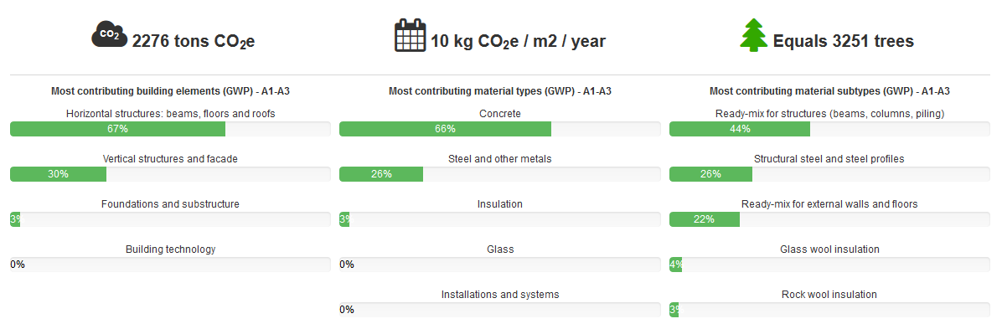
[Replace with picture of your own results]
Studied design options
[NOTE: studying design options is not required but we recommend it as it is an easy way to show how you have used LCA to steer the design process]
To steer the design process following design options were studied:
Design option | GWP emission change on building level | Conclusions
Choosing concrete from another manufacturer with different kind of cement | + 10 % | We found out that our concrete manufacturer was able to deliver concrete in which 15 % of the cement had been replaced with recycled fly ash. This option had approximately 10 % less impacts on building level than concrete without the recycled content so it was found out that chosen solution was good.
Choosing different kind of rebar steel | From + 5 % | Comparison between manufacturers showed that the steel we had chosen had a high recycled content and thus less emissions than compared steel option.
Replacing some of the external wall and roof insulation with renewable option | - 2 % | Changing to cellulose based insulation in suitable wall parts instead of Rock wool resulted with few small emission reduction. However, change would have required thicker walls which was not possible to change in this design stage.
Replacing some of the brick wall with reclaimed bricks | - 1 % | Reclaimed bricks had significantly lower impacts than average bricks but on whole building level the impact was minor. Changing to the bricks was studied but was not possible due to availability and cost.

The detailed comparison results for scenarios are shown below.
[Add here your result tables from One Click LCA.]
[Guidance: Add here the comparison result tables from proposed design that shows the percentage differences.]
Conclucions on how LCA helped to steer the design process:
[example:] LCA enabled design team to learn about their choices, to make some better choices and to ensure the current planned emission friendly choices were specified to further process steps. A10 % impact reduction was achieved by choosing concrete option with recycled fly ash replacing cement. Additionally the planned steel manufacturer was proven to be carbon efficient choice and thus using this manufacturer was specified for the following process steps. On the other hand, all of the more sustainable options found were not possible to execute because of the project schedule and availability of products. Starting LCA calculations earlier in the design process in next projects could in increase the available options.

Description of One Click LCA calculation tool
The calculations were performed with One Click LCA calculation tool. The software has been verified to be IMPACT compliant by BRE. The approval letter can be found here.

