Results for building life cycle assessment
According to EN 15978

Project name
Address: [Address, Country]
Assessor:
Client for assessment:
Date:

[Text marked with blue color and brackets contains guidance. Remove from the final report.]

Contents
1. Purpose of the study and description of the building 3
2. Life cycle impact assessment result summary 4
3. The life cycle assessment scope and service life 4
4. Description of the datasets 5
5. Material scope 5
6. Assumptions 6
7. Description of LCA calculation data 6
8. Detailed assessment results 7
9. Description of One Click LCA calculation tool 9

Purpose of the study and description of the building

Assessment basic information:

Purpose of the study: [purpose of the LCA study, e.g calculating climate emissions, building certification]
Project type: [new construction / renovation, point of assessment in building’s life cycle]
Assessment method: EN 15978:2011
Assessed building, general information:

Building type: [e.g. office, residential building]
Construction year:
Building area: [specify also the unit, dependent on the purpose of your LCA study, e.g. NFA, BTA, or other]
Building function(s) and service(s): [Description of building use / functions including areas of different functions]
Extent of use: [number of users / occupants, pattern of use/occupancy]
Relevant technical and functional requirements: [Building use and technical information. Describe shortly
Technical, functional and qualitative properties of the building such as:
- building form e.g. high rise, low rise, free-standing or detached, number of floors
- servicing type e.g. heating, cooling, ventilation and hot water service system type, are the systems centralized
- conditions of use (according to national energy performance calculation method)
- other relevant client or regulatory requirements]
Required service life: [Service life of the building required by the client or through regulations, for LCA this is also the reference study period / calculation period for the analysis]

Life cycle impact assessment result summary
The life cycle assessment was calculated using One Click LCA. The results are summarized in the following table. The results represent the total life cycle impact during [enter here required service life / calculation period] year service life.
Impact category | Unit | Results [Total]
Global warming potential (greenhouse gases) | kgCO₂ eq
Acidification potential | kgSO₂ eq
Eutrophication potential | kgPO₄-eq
Ozone depletion potential | kgCFC₁₁eq
Formation of ozone of lower atmosphere | kgC₂H₄eq
Primary energy | MJ

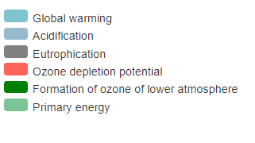
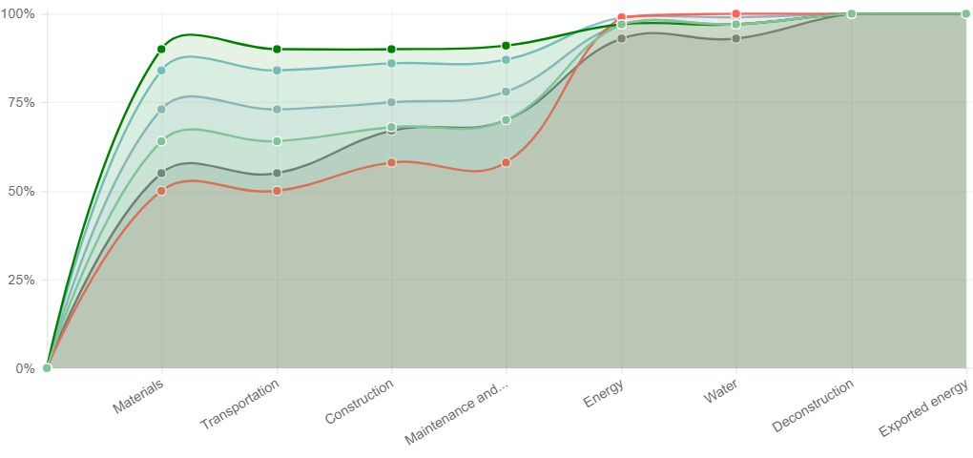
[Insert here your summary graph of results (download from project result page).]

The life cycle assessment scope and system boundaries
In the assessment following life cycle stages according to EN 15804:2012 were included:
Product Stage |  |  | Construction Process Stage |  | Use Stage |  |  |  |  |  |  | End-of-Life Stage |  |  |  | Benefits and loads beyond the system boundary
Raw material supply | Transport | Manufacturing | Transport to building site | Installation into building | Use/application | Maintenance | Repair | Replacement | Refurbishment | Operational energy use | Operational water use | Deconstruction/demolition | Transport | Waste processing | Disposal | Reuse | Recovery | Recycling
A1 | A2 | A3 | A4 | A5 | B1 | B2 | B3 | B4 | B5 | B6 | B7 | C1 | C2 | C3 | C4 | D | D | D
x |  |  | x | x | x |  |  |  |  | x | x | x |  |  |  | x

Description of the life cycle stages and analysis scope are provided in the table below:
A1-A3 Construction Materials | Raw material supply (A1) includes emissions generated when raw materials are taken from nature, transported to industrial units for processing and processed. Loss of raw material and energy are also taken into account. Transport impacts (A2) include exhaust emissions resulting from the transport of all raw materials from suppliers to the manufacturer’s production plant as well as impacts of production of fuels. Production impacts (A3) cover the manufacturing of the production materials and fuels used by machines, as well as handling of waste formed in the production processes at the manufacturer’s production plants until end-of-waste state.
A4 Transportation to site | A4 includes exhaust emissions resulting from the transport of building products from manufacturer’s production plant to building site as well as the environmental impacts of production of the used fuel.
A5 Construction/installation process | A5 covers the exhaust emissions resulting from using energy during the site operations, the environmental impacts of production processes of fuel and energy and water as well as handling of waste until the end-of-waste state.
B1-B5 Maintenance and material replacement | The environmental impacts of maintenance and material replacements (B1-B5) include environmental impacts from replacing building products after they reach the end of their service life. The emissions cover impacts from raw material supply, transportation and production of the replacing new material as well as the impacts from manufacturing the replacing material as well as handling of waste until the end-of-waste state.
B6 Energy use | The considered use phase energy consumption (B6) impacts include exhaust emissions from any building level energy production as well as the environmental impacts of production processes of fuel and externally produced energy. Energy transmission losses are also taken into account.
B7 Water use | The considered use phase water consumption (B7) impacts include the environmental impacts of production processes of fresh water and the impacts from waste water treatment.
C1-C4 Deconstruction | The impacts of deconstruction include impacts for processing recyclable construction waste flows for recycling (C3) until the end-of-waste stage or the impacts of pre-processing and landfilling for waste streams that cannot be recycled (C4) based on type of material. Additionally deconstruction impacts includes emissions caused by waste energy recovery.
D External impacts/end-of-life benefits | The external benefits include emission benefits from recycling recyclable building waste. Benefits for re-used or recycled material types include positive impact of replacing virgin based material with recycled material and benefits for materials that can be recovered for energy cover positive impact for replacing other energy streams based on average impacts of energy production.

Assessed impact categories
Impact category | Unit | Description
Global warming potential (greenhouse gases) | kgCO₂ eq | Describes changes in local, regional, or global surface temperatures caused by an increased concentration of greenhouse gases in the atmosphere. Greenhouse gas emissions from fossil fuel burning has been strongly correlated with two other impact categories: acidification and smog. Often called “carbon footprint”.
Acidification potential | kgSO₂ eq | Describes the acidifying effect of substances in the environment. Substances such as carbon dioxide dissolve readily in water, increasing the acidity, which contributes to global phenomena such as ocean acidification (IPCC 2014).
Eutrophication potential | kgPO₄-eq | Describes the effect of adding mineral nutrients to soil or water, which causes certain species to dominate an ecosystem, compromising the survival of other species and sometimes resulting in die-off of populations.
Ozone depletion potential | kgCFC₁₁eq | Describes the effect of substances in the atmosphere to degrade the ozone layer, which absorbs and prevents harmful solar UV rays from reaching Earth’s surface.
Formation of ozone of lower atmosphere | kgC₂H₄eq | Describes the effect of substances in the atmosphere to create photochemical smog. Also known as summer smog.
Primary energy | MJ

Analysis material scope
The LCA analysis included following building elements:
Element | Included | Comments [mark if something is not relevant or add other notes]
SUPERSTRUCTURE
Frame | Yes/No
Upper floors | Yes/No
Roof | Yes/No
Stairs | Yes/No
External Walls | Yes/No
Windows & External doors | Yes/No
Internal Walls and Partitions | Yes/No
Internal Doors | Yes/No
INTERNAL FINISHES
Wall Finishes | Yes/No
Floor Finishes | Yes/No
Ceiling Finishes | Yes/No
BUILDING FITTINGS & FURNISHINGS
Fixed fittings and equipment | Yes/No
SERVICES
Sanitary Fittings | Yes/No
Services Equipment | Yes/No
Disposal Installations | Yes/No
Water Installations | Yes/No
Heat Source | Yes/No
Space Heating and Air Treatment | Yes/No
Ventilation Systems | Yes/No
Electrical Installations | Yes/No
Gas Installations | Yes/No
Lift Installations | Yes/No
Protective Installations, inc. internal CCTV | Yes/No
Communication Installations | Yes/No
Specialist Installations | Yes/No
EXTERNAL WORKS
Site works | Yes/No
Drainage | Yes/No
External services | Yes/No

Environmental data sources
One Click LCA LCA EN-15978 tool was used in the assessment. The tool supports CML (2002 - November 2012 or newer) methodology and all assessed impact categories. All of the datasets in the tool follow EN 15804 standard. A complete list of data sources is presented in attachment 1.

Project data sources and assumptions
The proposed building was calculated in One Click LCA based on design data from [add here the description of the datasource and how analysis was executed.]
Area of analysis | Data sources
Material quantities (A1-A3) | [List design data source used such as building information model, architectural drawings etc. ]
Building material transport distances (A4) | [Define if project specific transport distances or tool averages were used. For instance: The case specific transport distances were used when available. Other transport distances were estimated based on typical average transport distances based on material type provided by calculation tool.]
Construction and installation process (A5) | [Define if you used project specific data or average scenarios. For instance: Calculation tool average construction process emissions based on project size were used in the analysis.]
Material service life (B1-B5) | [Define how the material service lives were estimated. For instance: The service life information for each material was checked and project specific values were used when available. Otherwise default values from One Click LCA database were used.]
Building use phase energy consumption (B6) | [Define which source you used e.g. energy modelling, energy certificate etc. For instance: Energy consumption was estimated based on design stage energy simulation with project specific use scenarios].
Building use phase energy consumption (B7) | [Define which source you used. For instance: Water consumption was estimated based on typical water consumption for office buildings].

Other assumptions (if relevant):
[List here all assumptions made for the assessment; e.g. if some elements were left out from the LCA; some material quantities were rounded or estimated; and similar]
Material / construction / area of LCA | Comment

Detailed assessment results
[Copy here charts and tables from the results page. Dependent on the purpose of your study, you can additionally add charts for different impact categories.]
Result summary
 |  | Global warming  kg CO2e | Acidification  kg SO2e | Eutrophication  kg PO4e | Ozone depletion potential  kg CFC11e | Formation of ozone of lower atmosphere  kg Ethenee | Primary energy  MJ
A1-A3 | Construction Materials | 1,73E4 | 7,72E1 | 1,49E1 | 4,16E-4 | 6,39E0 | 4,73E5
A4 | Transportation to site | 5,32E2 | 1,86E0 | 4,02E-1 | 9,97E-5 | 4,75E-2 | 1,27E4
A5 | Construction/installation process | 9,1E4 | 3,29E2 | 2E2 | 1,3E-2 | 1,12E1 | 1,7E6
B1-B5 | Maintenance and material replacement
B6 | Energy use | 3,28E3 | 1,48E1 | 1,68E0 | 7,23E-4 | 7,32E-1 | 9,34E4
B7 | Water use | 2,08E2 | 1,45E0 | 4,16E0 | 2,09E-5 | 6,09E-2 | 3,75E3
C1-C4 | Deconstruction | 2,57E2 | 1,77E0 | 4,05E-1 | 3,98E-9 | 2,36E-1 | 5,02E3
D | External impacts (not included in totals) | -2,99E1 | -5,39E-2 | -9,45E-3 | -1,21E-8 | -3,4E-3 | -4,97E2
 | Total | 1,13E5 | 4,26E2 | 2,21E2 | 1,43E-2 | 1,86E1 | 2,29E6

Results for Global warming potential (GWP), kgCO2 eq
Describes changes in local, regional, or global surface temperatures caused by an increased concentration of greenhouse gases in the atmosphere. Greenhouse gas emissions from fossil fuel burning has been strongly correlated with two other impact categories: acidification and smog. Often called “carbon footprint”.
The major contributors for global warming potential GWP emissions were [Add here any conclusions from the analysis].
[Add here text explaining your chart]
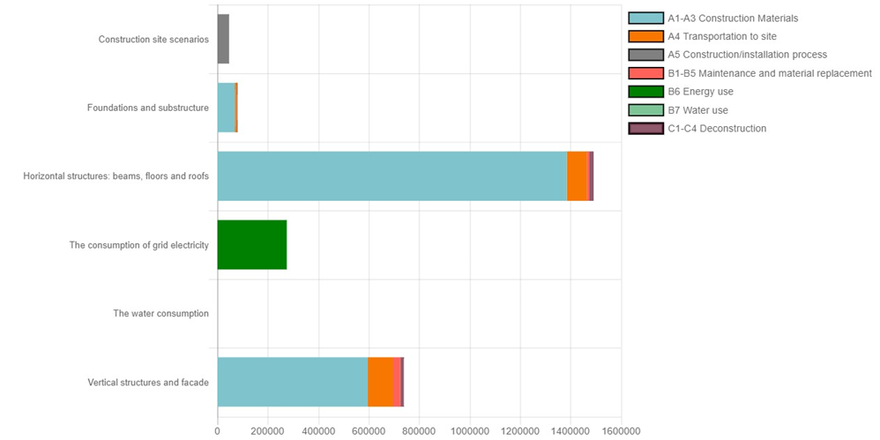
[Add here text explaining your charts]

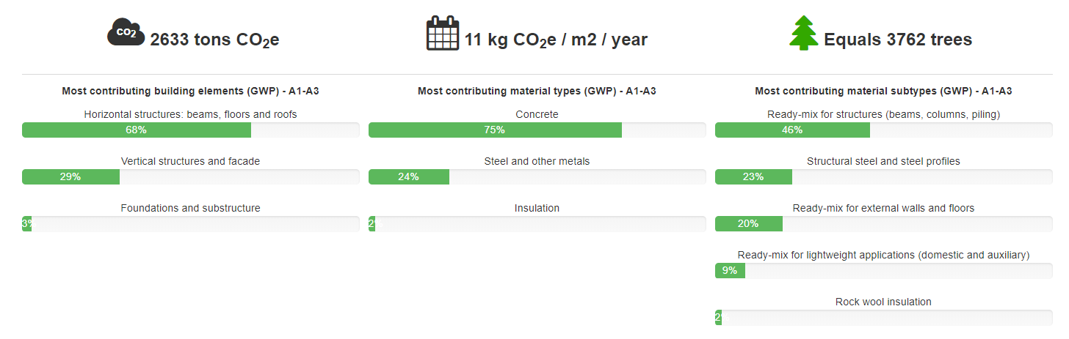
Results for Acidification potential (ADP), kgSO2 eq
Describes the acidifying effect of substances in the environment. Substances such as carbon dioxide dissolve readily in water, increasing the acidity, which contributes to global phenomena such as ocean acidification (IPCC 2014).
The major contributors for acidification potential were [Add here any conclusions from the analysis].

Results for Eutrophication potential (EP) kgPO4-eq
Describes the effect of adding mineral nutrients to soil or water, which causes certain species to dominate an ecosystem, compromising the survival of other species and sometimes resulting in die-off of populations.
The major contributors for eutrophication potential were [Add here any conclusions from the analysis].

Results for Ozone depletion potential (ODP), kgCFC11eq
Describes the effect of substances in the atmosphere to degrade the ozone layer, which absorbs and prevents harmful solar UV rays from reaching Earth’s surface.
The major contributors for ozone depletion potential were [Add here any conclusions from the analysis].

Results for Formation of ozone of lower atmosphere (POCP), kgC2H4eq
Describes the effect of substances in the atmosphere to create photochemical smog. Also known as summer smog.
The major contributors for formation of ozone in lower level atmosphere were [Add here any conclusions from the analysis].

Primary energy, MJ

Description of One Click LCA calculation tool
The calculations were performed with One Click LCA calculation tool. The software is fully compliant with EN 15978 standard. One Click LCA has been third party verified by ITB for compliancy with the following LCA standards: EN 15978, ISO 21931–1 and ISO 21929, and data requirements of ISO 14040 and EN 15804. You can find the official letters of compliancy here: https://www.oneclicklca.com/wp-content/uploads/2016/11/360optimi-verification-ITB-Certificate-scanned-1.pdf.
ITB is a certification organization and a Notified Body (EC registration nr. 1488) to the European Commission designated for construction product certification. Polish Accreditation Board assures the independence and impartiality of ITB services (Accreditation Certificates are: AB 023, AC 020, AC 072, AP 113). ITB activities are conducted in accordance to the requirements of the following assurance standards: ISO 9001, ISO/IEC 27001, ISO/IEC 17025, EN 45011, and ISO/IEC 17021.

Attachment 1, sources:
[Copy the table from software.]
Resource name | Date | Environment Data Source | Standard | EPD program | PCR | Notes about PCR | Upstream DB | Verification
Concrete (ex rebar) | 2013 | Concrete and reinforced concrete prefabricates, Scanbet 2013 | EN15804 | ITB | PCR UN CPC 375 | Only with EN15804 | - | Verified
Concrete column, precast, reinforced | 2014 | Columns, Skonto Prefab SIA 2014 | EN15804 | EPD Norge | NPCR 020 Precast Concrete Products, 03-2012 | Only with EN15804 | ecoinvent | Verified
Insulation, rock wool/mineral wool | 2014 | EPD Paroc Insulation, product group with density 70-120 kg/m³, Paroc AB | EN15804 | EPD Norge | NPCR 12 Rev 1 Insulation materials. LCA of PAROC stone wool produced at Scandinavian plants. | Only with EN15804 | GaBi | Verified
Mineral wool (interior insulation) | 2015 | Oekobau.dat | EN15804 | OKOBAUDAT | EN15804 | Only with EN15804 | GaBi | Verified
Profiled steel sheeting, hot-dip galvanized | 2014 | Kuumasinkityt rakennustuotteet, Ruukki 2015 | EN15804 | - | EN15804 | - | GaBi | Verified
Ready mix concrete, excluding rebar | 2015 | B30 M60 D22 Synk 180, Sandnes Betong AS | EN15804 | EPD Norge | EN15804 | - | ecoinvent | Verified
Ready mix concrete, excluding rebar | 2014 | B20 M90 D22 Synk 180, Sandnes Betong AS | EN15804 | EPD Norge | EN15804 | - | ecoinvent | Verified
Ready-mix concrete for indoor floor appl. | 2017 | EPD Betong för bjälklag inomhus, standard Svensk Betong | EN15804 | IBU | EN 15804:2012+A1:2013 | Only with EN15804 | ecoinvent | Verified
Ready-mix concrete, French average | 2016 | MDEGD_FDES | EN15804 | INIES | EN15804 | EN15804 | ecoinvent | -
Reinforcement steel | 2015 | Oekobau.dat | EN15804 | OKOBAUDAT | EN15804 | Only with EN15804 | GaBi | Verified
Steel hot rolled, I, H, U, L, T and wide flats, FI average | 2014 | EPD Ympäristöseloste teräsrakenteet, Kuumavalssatusta levystä ja kelasta valmistetut, hitsatut ja pintakäsitellyt profiilit, ristikkorakenteet ja palkit , Ruukki 2014 | EN15804 | - | EN15804 | - | GaBi | Verified
Steel, cold formed, structural hollow sections | 2013 | Cold formed structural hollow sections (CFSHS), NEPD 00079E Rev1, Contiga AS | EN15804 | EPD Norge | NPCR 013 Steel as construction material Rev 1, 08-2013 | Only with EN15804 | GaBi | Verified
Steel, hot rolled, structural steel as plates | 2015 | World Steel Association; Plate | ISO14040 | - | LCI methodology for steel products | Only with EN15804 | GaBi | -

